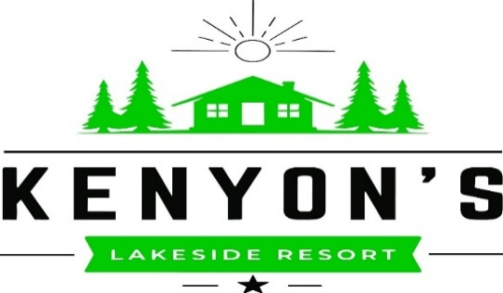
Kenyonslakesideresort.com

**Visit our Facebook page for our weekly specials**

Pizza 12” small…$17 16” large…$20
Hand Tossed pizza with house made sauce, mozzarella cheese & your choice of the following toppings…
Pepperoni, Sausage, Ham, Bacon, Mushrooms, Onions, Green Peppers, Black Olives,
Green Olives, Mild Pepper Rings, Pineapple

Garlic – Mozzarella Cheesy Bread $12

Appetizers Resort Favorites - Served with side salad or slaw
Breaded Wings (6) $12 Seafood Mac & Cheese $18
Chicken Tenders (4) $9 Fish & Chips (tots) $16
Breaded Cheese Curds $10 Dry batter, or Beer batter
Brussel Sprouts $10 Chicken Pot Pie $10
Appetizer Basket $15 Meatloaf Dinner $10
Tenders (4) & Tots Basket $12

Sandwiches - All sandwiches served with golden tots
The Boat Slip Burger $14
½ pound burger grilled to your liking, presented on a toasted brioche bun, with lettuce, tomato and onion.
Add any of the following to your burger for an additional $2 per item…American cheese, swiss cheese,
blue cheese, cheddar cheese, bacon, sauteed mushrooms, sauteed onions, green olives.
Grilled Chicken Sandwich $13
Grilled breast of chicken topped with swiss cheese on a toasted brioche bun.
Try the chicken sandwich with either a sweet thai chili sauce, or a spicy boom-boom sauce.
The Sage Lake Club Wrap $14
Ham, turkey, american and swiss cheese, bacon, lettuce, tomato, wrapped in a giant flour tortilla.
The Italian Ciabatta Sandwich $14
Shaved ham, hard salami, and pepperoni with sliced tomato, shredded lettuce, provolone cheese, and italian dressing on a grilled asiago ciabatta roll. Presented hot.
The Fish Sandwich $8
Beer battered or dry battered cod with american cheese on a golden brioche bun.

Salads
Spinach Salad $14
Tender baby spinach is topped with roasted pecans, dried apricots, dried cherries, slivered red onion,
grape tomatoes, sliced cucumber, and grilled chicken.
Antipasti Salad $14
Crisp Romaine topped with grape tomatoes, sliced cucumbers, slivered ham and salami, provolone cheese,
black olives, and garbanzo beans.

Children’s Menu

All-beef Hot dog $5
Served with golden tots
Golden Chicken Tenders (3) $7
Served with golden tots and a choice of the following…
BBQ, ranch, or honey-mustard dipping sauce.
Grilled Cheese $5
Served with golden tots and your choice of the following cheese…
American, swiss, or cheddar.
Macaroni & Cheese $5

“Ask your server about menu items that are cooked to order or served raw.
Consuming raw or undercooked meats, poultry, seafood, shellfish, or eggs may increase your risk of foodborne illness.”

